I am going to the NGV. The letters N-G-V stand for National Gallery of Victoria. I can also call it the Gallery.
The Gallery is a very large building in the city of Melbourne. It has lots of art works from all over the world including pictures and objects. I can look, listen and explore at the Gallery.

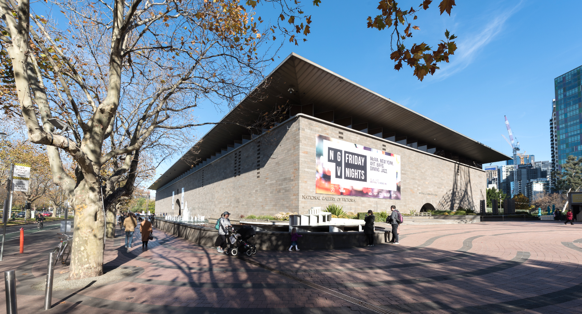
When I arrive, I will see a big pool of water out the front. This is called a moat. I can walk along the footpath next to the moat.

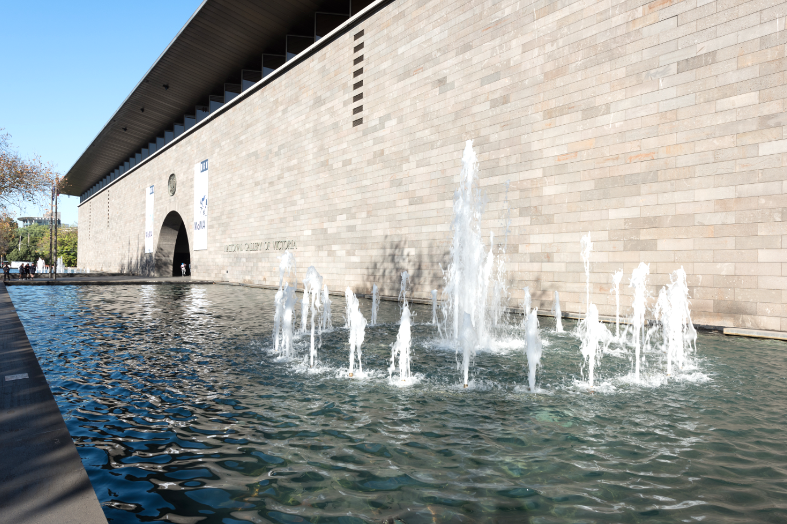

I will look for a big archway and a glass wall with water running down it.
This is called the Waterwall.

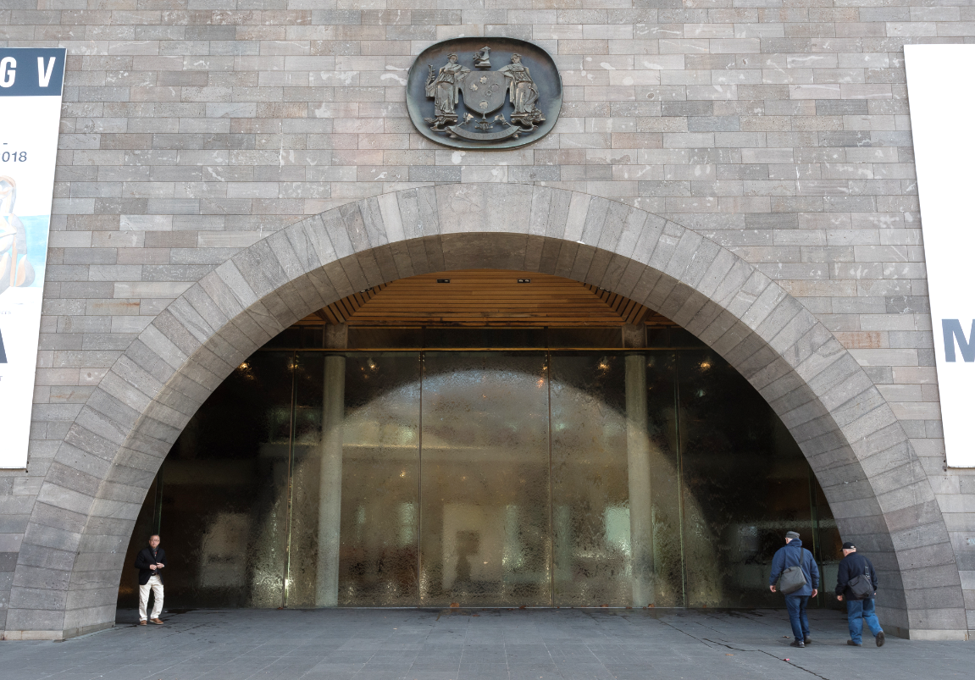
The Waterwall is made of very thick and strong glass and it will not break. I can touch the Waterwall. My hands and maybe my clothes will get wet if I do.

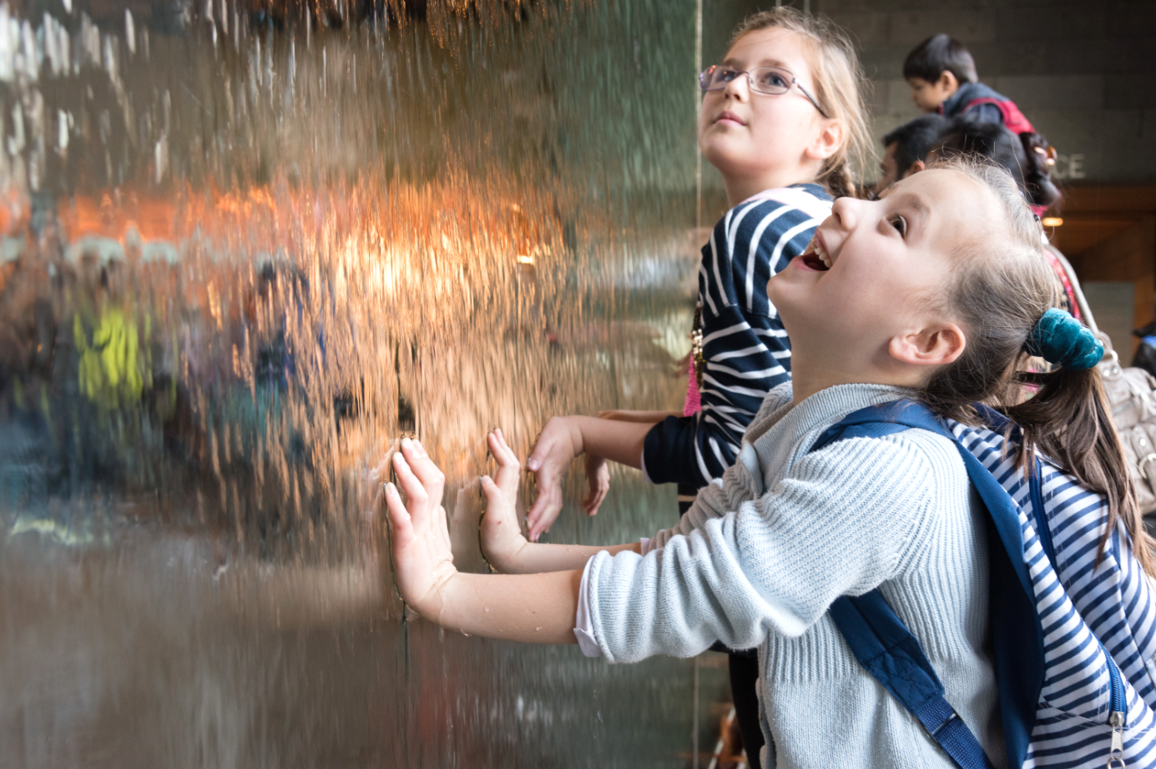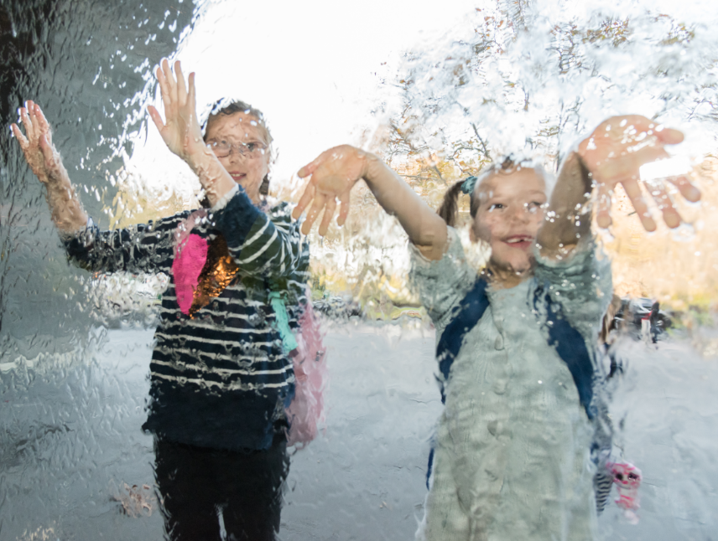

I will walk through the archway and use the door on the right hand side of the Waterwall.

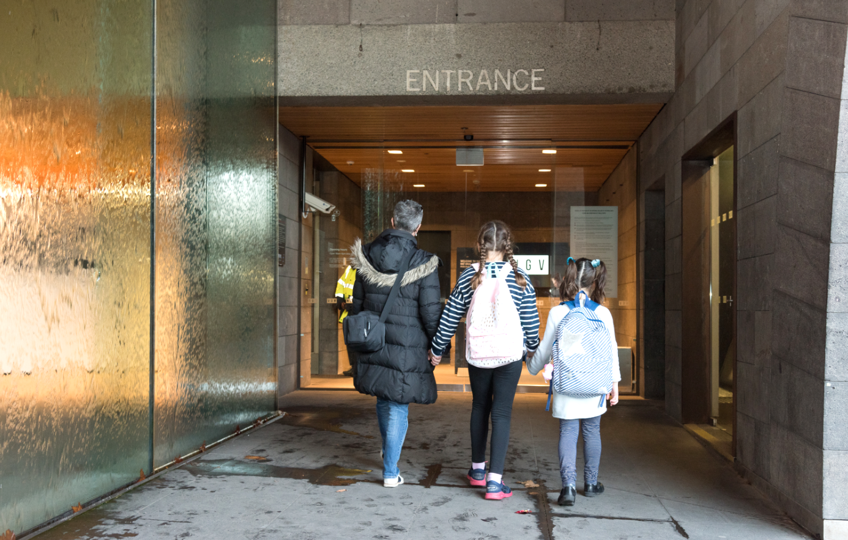

The area inside the main entrance is called the foyer. This is where people can buy tickets or ask for directions. Sometimes there are lots of people in the foyer. We won’t stay here for long.

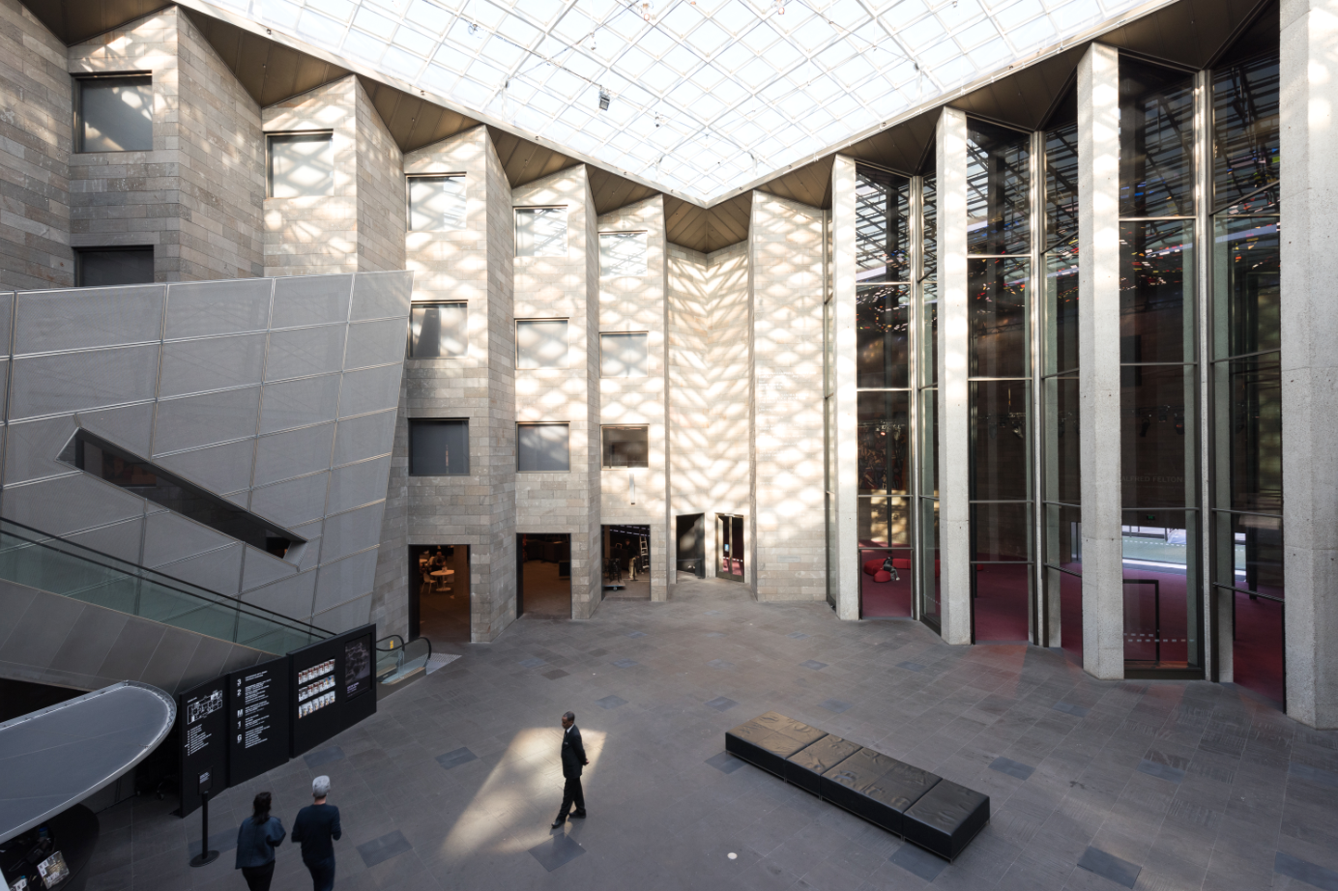

If I have a backpack and coat, I will leave them in the cloakroom. There is a staff member at the cloakroom who will look after my things. I will get them back later. Sometimes this area is busy and noisy. There may be a line to use the cloakroom and I may have to wait. This is okay.

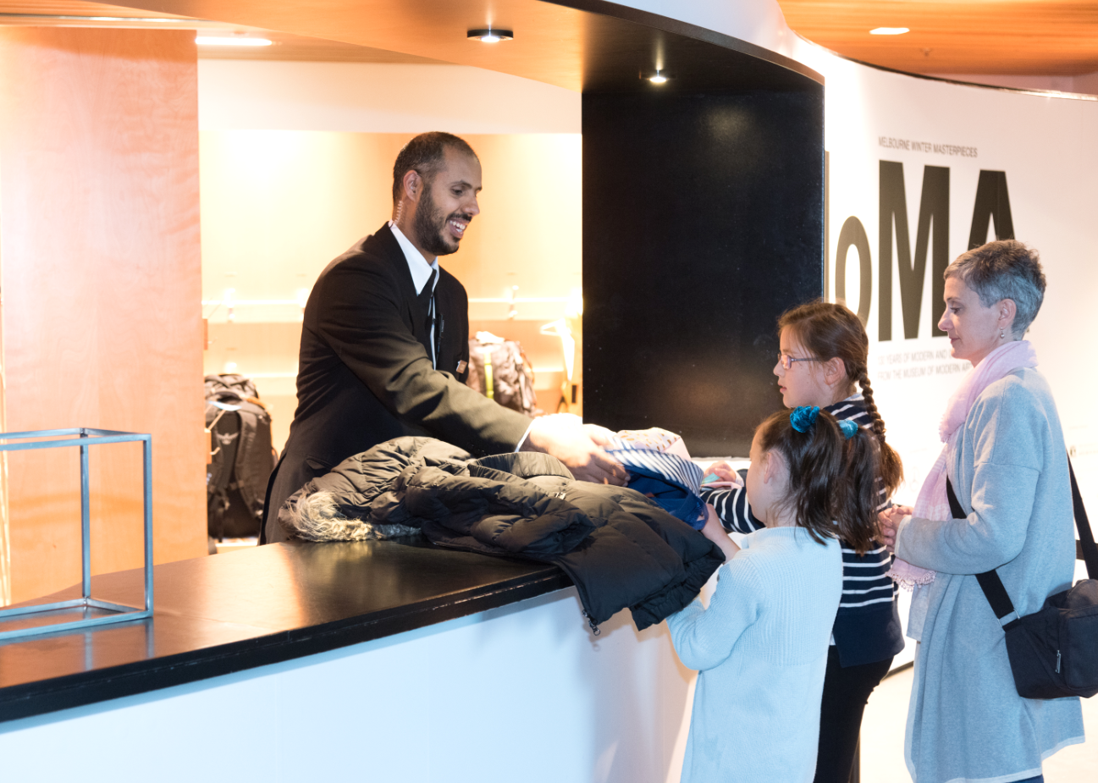
I will see staff in the gallery spaces. They wear a black uniform. They are there to help people and to keep the artworks and people safe. I can ask them for help at the Gallery.

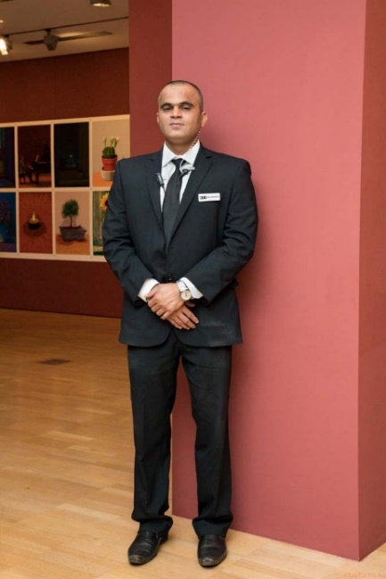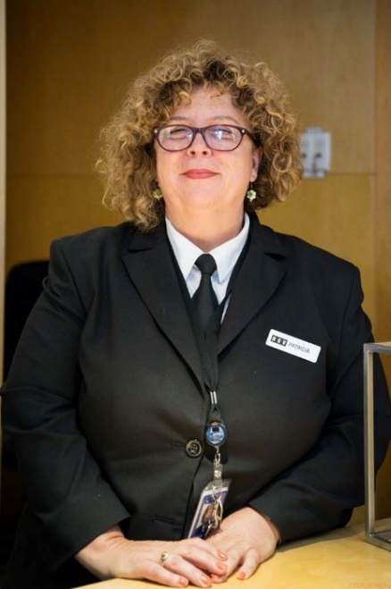

Other Gallery staff wear black and white t-shirts with the letters N-G-V printed on them.

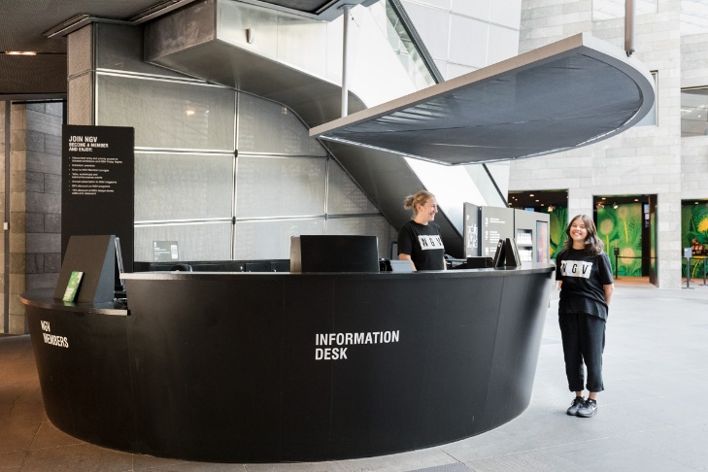
There are lots of people who work at the Gallery and the people in these photos may not be there when I visit. I can ask people in the same clothing for help if I need it. The staff at the Gallery are friendly and they will help me.
I will see different types of art at the Gallery. I might see paintings, sculptures, photographs, drawings, furniture, films or ancient objects.

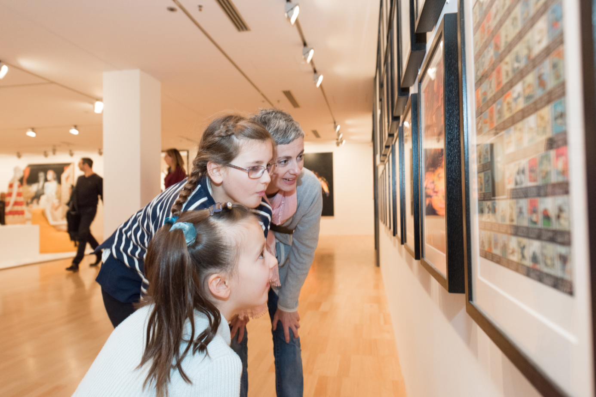

The art can be big or small. Some might even be bigger than me. Sometimes artworks may have bright lights or make noises. If I don’t like this, I will let my adult know and we can go to another area.

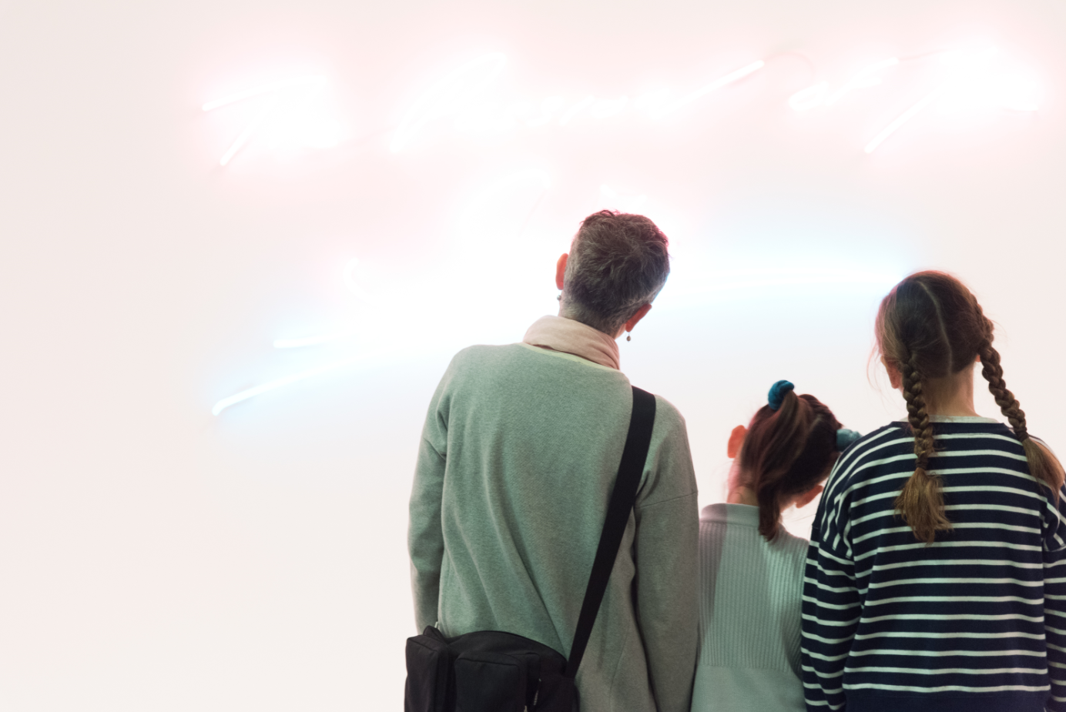
Some important things to remember at the Gallery
The artworks, display cases or walls inside the Gallery spaces are for looking only. This is important to keep the artwork clean and safe. If I am not sure whether I can touch something, I will ask an adult.

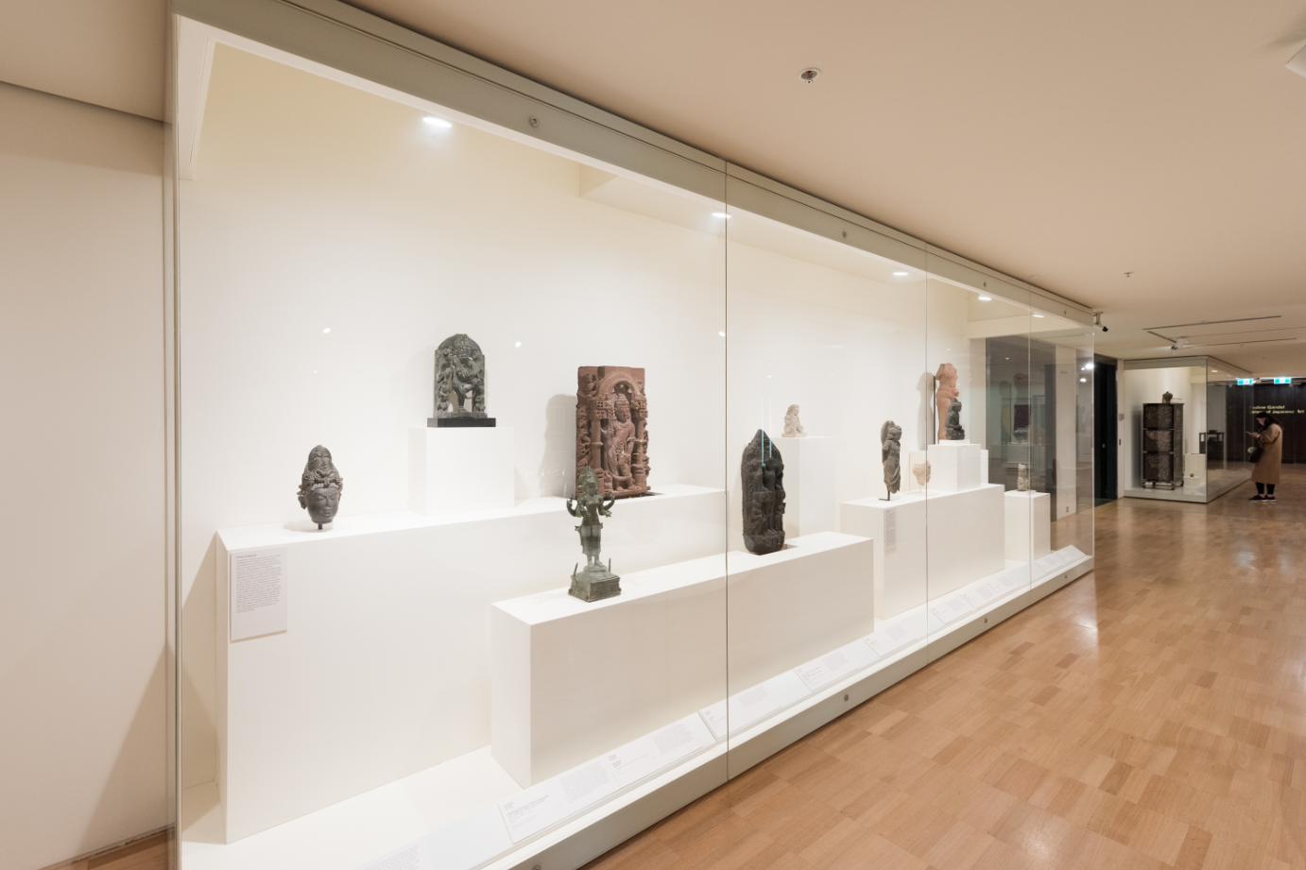
When I am at the Gallery, I must also remember to:
- Stay with my adult
- Walk and not run
- Speak with my inside quiet voice, even though it may be noisy
- Wait my turn
- Ask my adult before I touch things

The Gallery has lots of levels and many rooms. There are escalators and lifts to take people to the other levels.
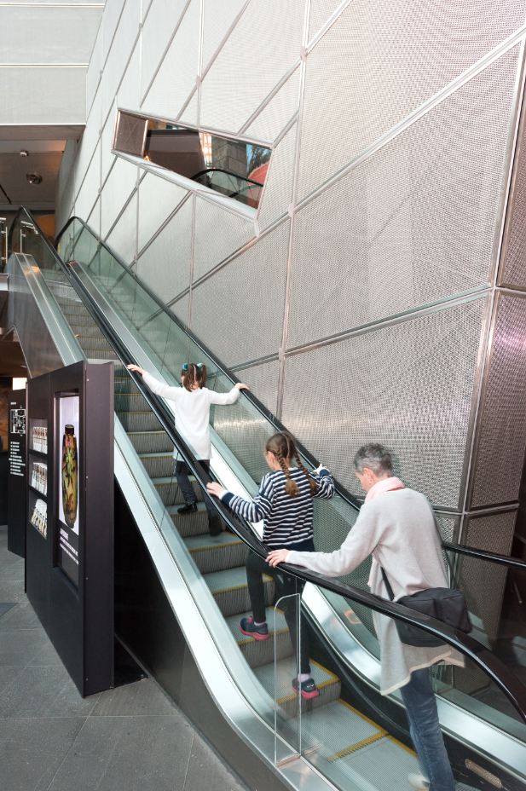

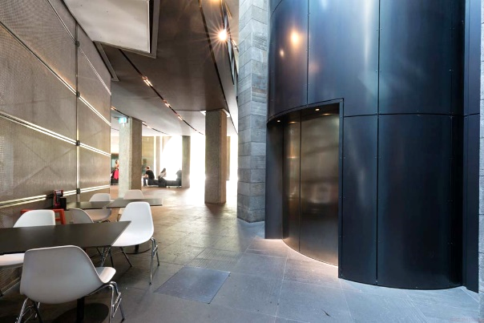
Some of the floors are made of glass. I may see people walking above me on a glass floor. This floor is made of very strong glass and it will not break. This floor is held up by strong metal and it will not fall on me.

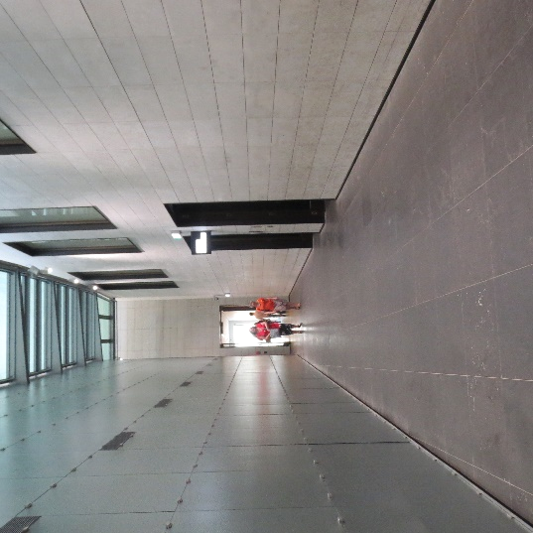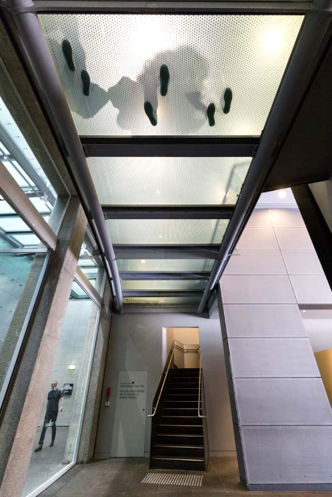

There are some big spaces with high walls in the Gallery. Sometimes these spaces are busy and noisy. Sometimes they are quiet. Some rooms in the Gallery might be dark or bright. If I don’t like being in a room I will tell my adult.
The Great Hall is a very big room with a colourful roof. There are big poles in the middle of the room which hold up the roof. It will not fall on me.

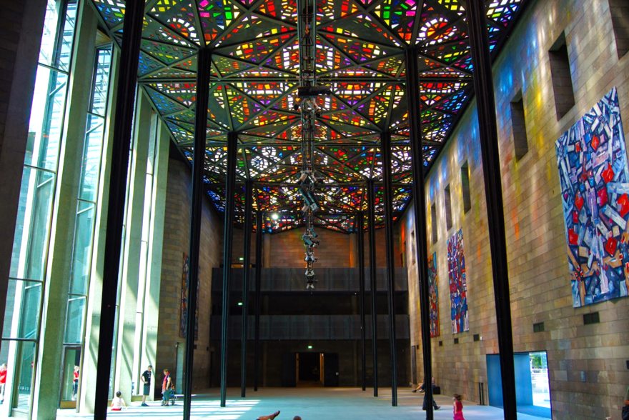
Sometimes people lie on the floor and look up at the colourful ceiling. I can lie down and have a look too.

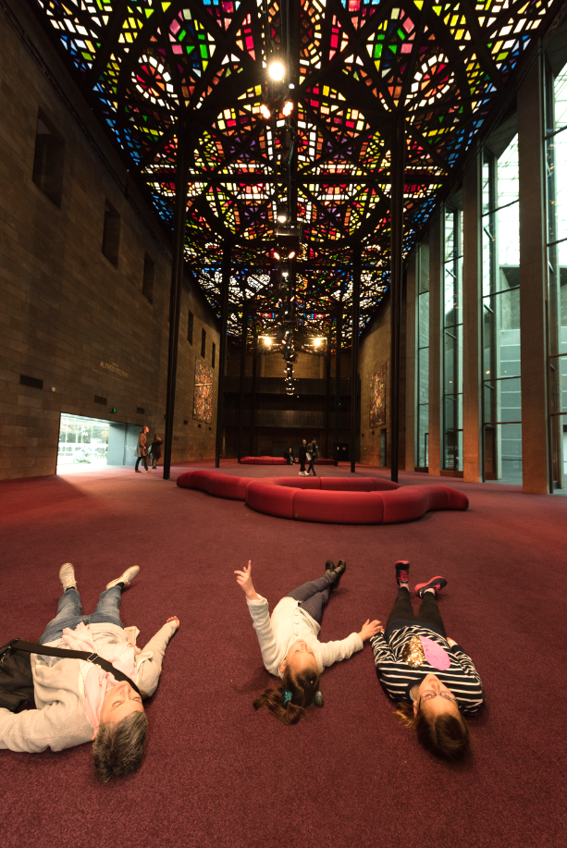
The Gallery has a big garden outside where I can play. There is another moat in the garden with a bridge which goes over it. I can cross the bridge to go to the other end of the garden.

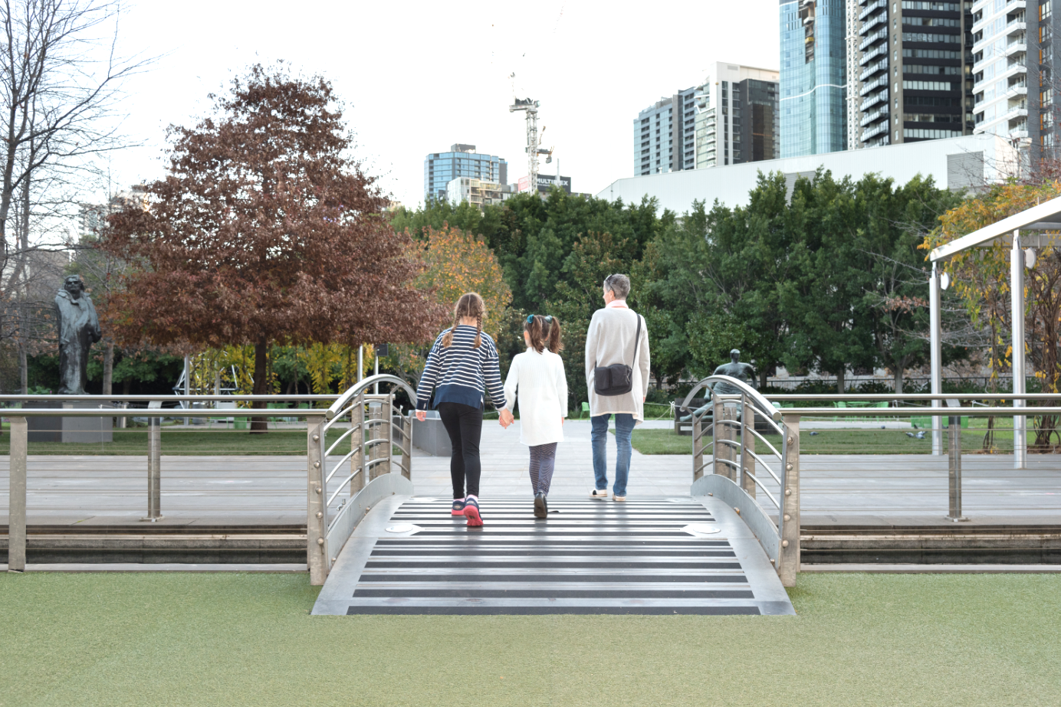
There is a climbing frame that I can play on.

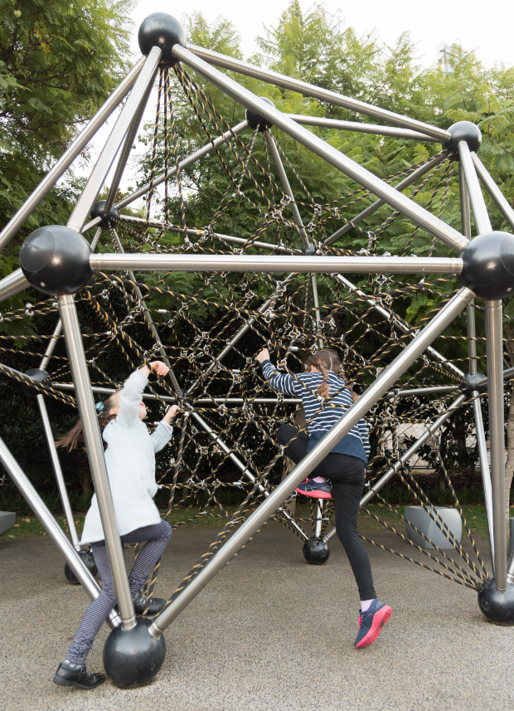

There are also some sculptures in the Garden. These are artworks and are for looking at.

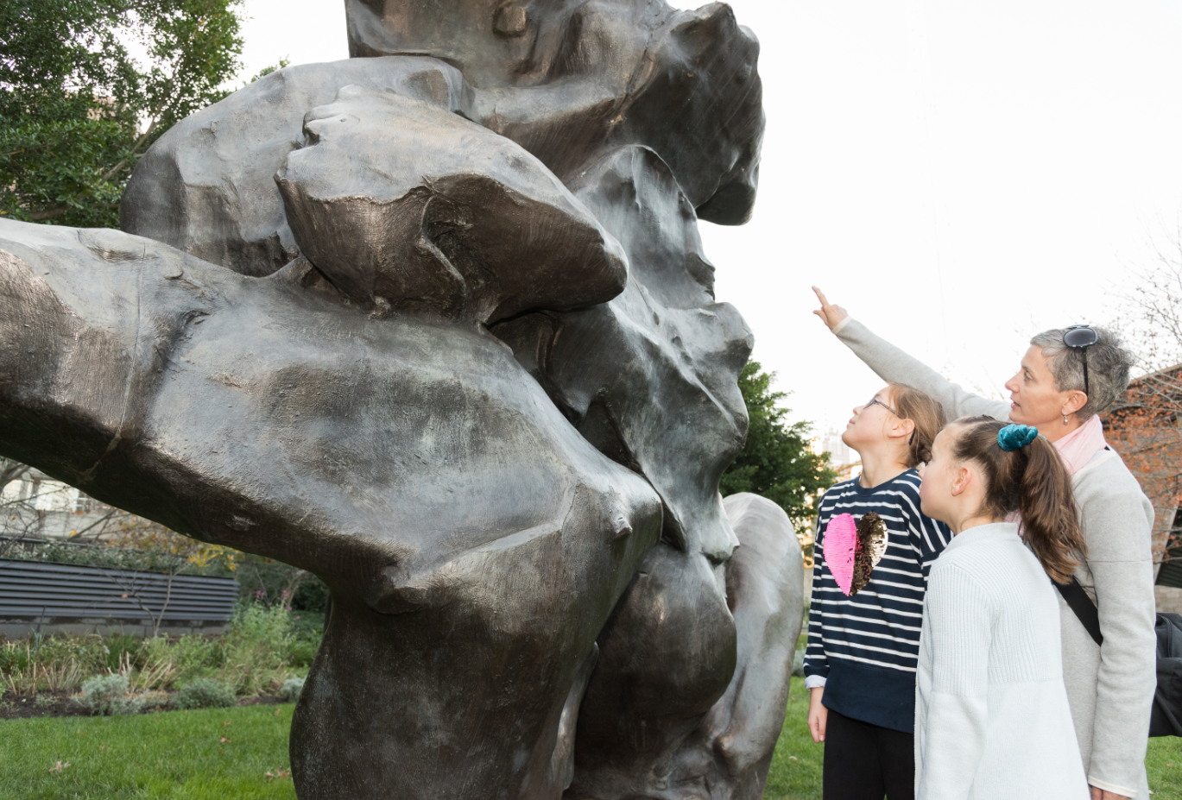

There are lots of toilets at the Gallery. If I need to go to the toilet, I can ask one of the Gallery staff how to find it.
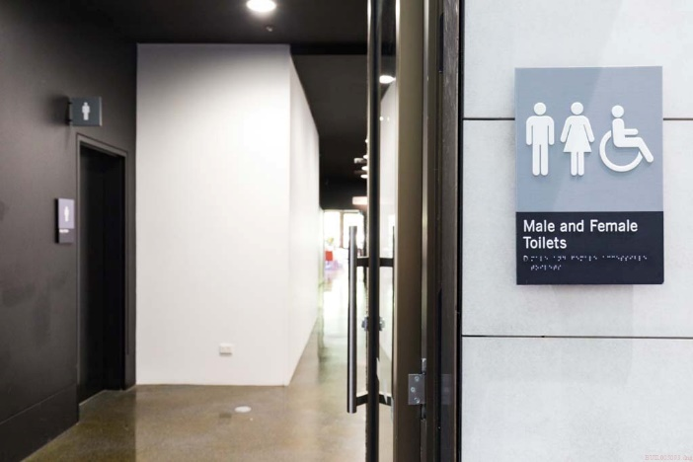
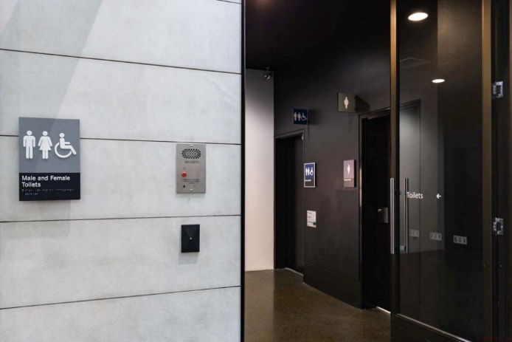

I can buy food at the Gallery or eat food brought from home.

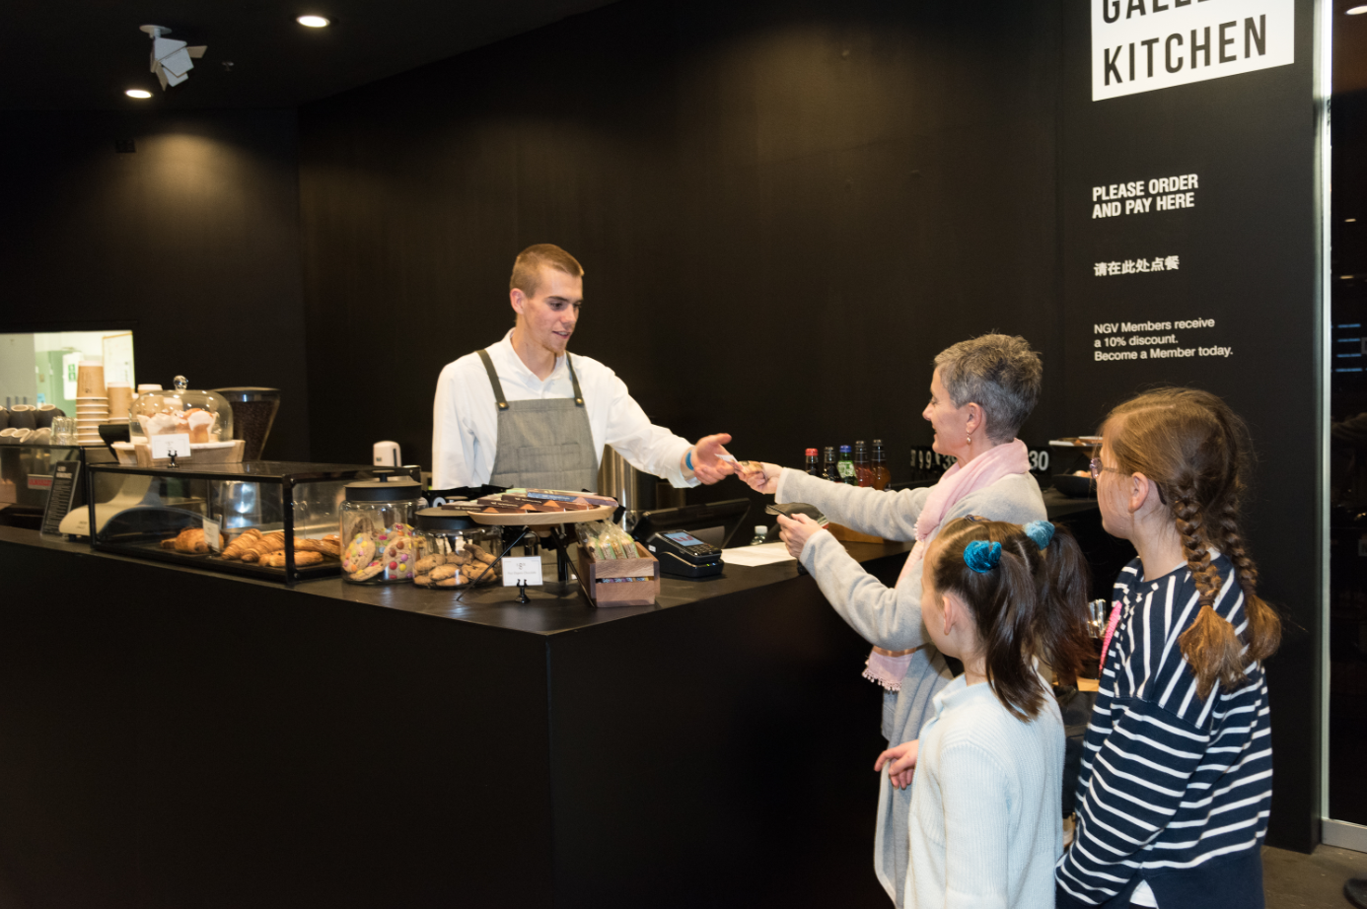

I can go and sit in the Great Hall or outside to the garden to eat my food.

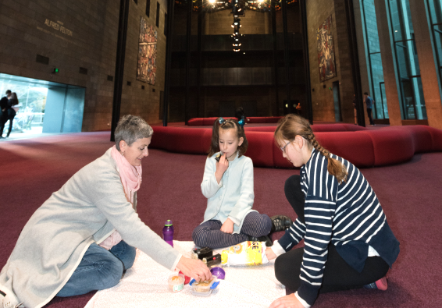

During my visit, I may go to the NGV design store. The store sells books, postcards and even clothes. I will ask my adult before I touch things.

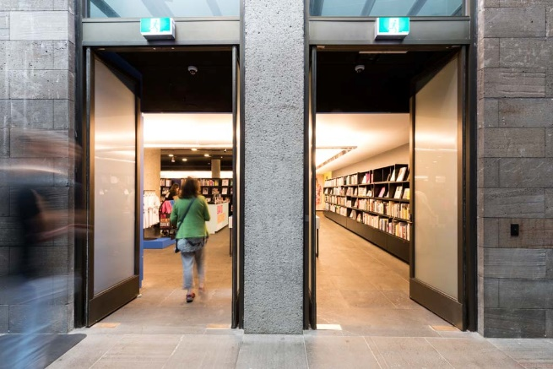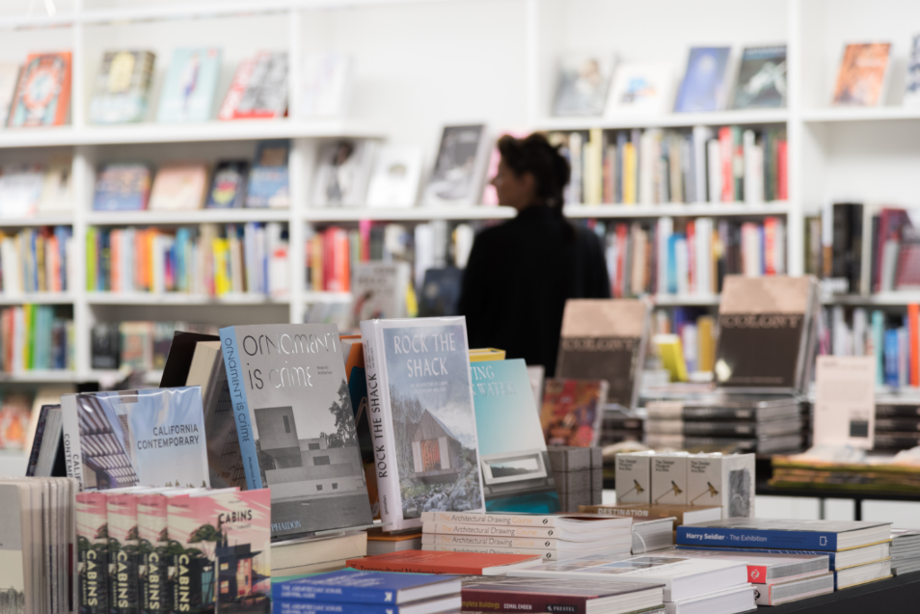

When I am ready to leave, I will go and pick up my bag if I left it in the cloakroom. I may have to wait. This is okay.

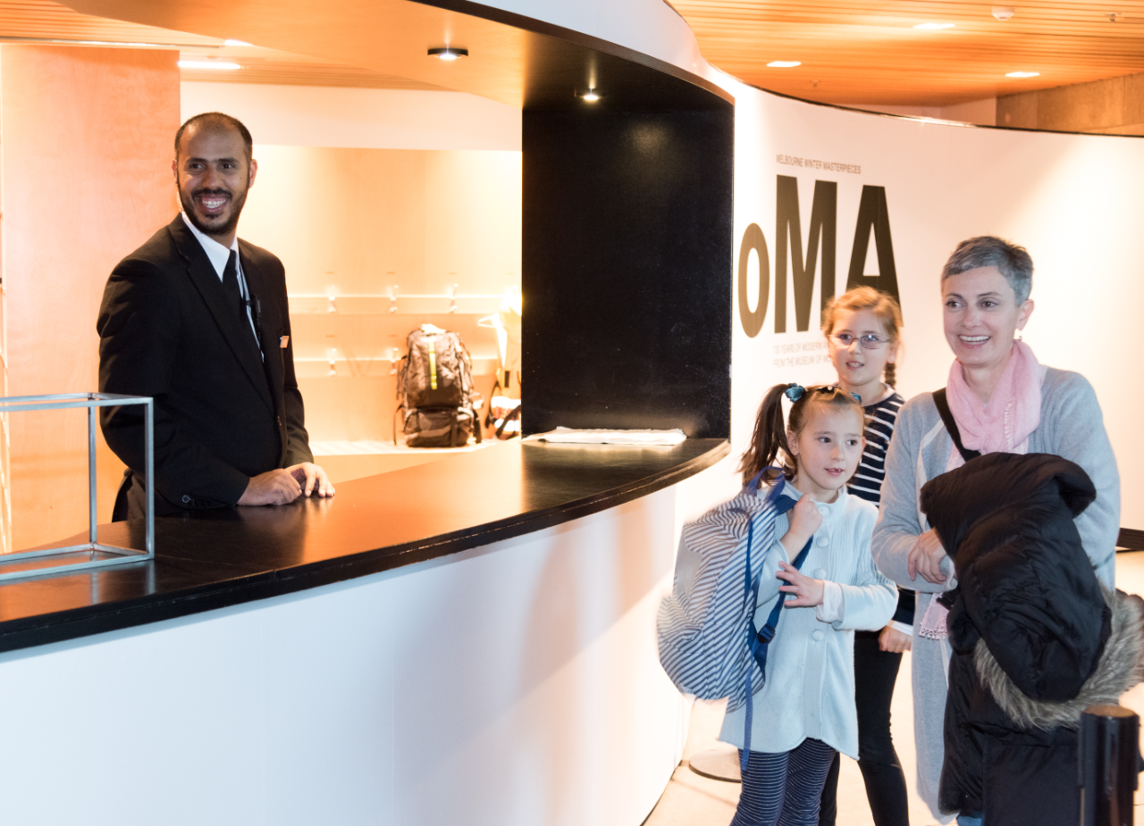
I will leave the Gallery through the door on the right hand side of the Waterwall.

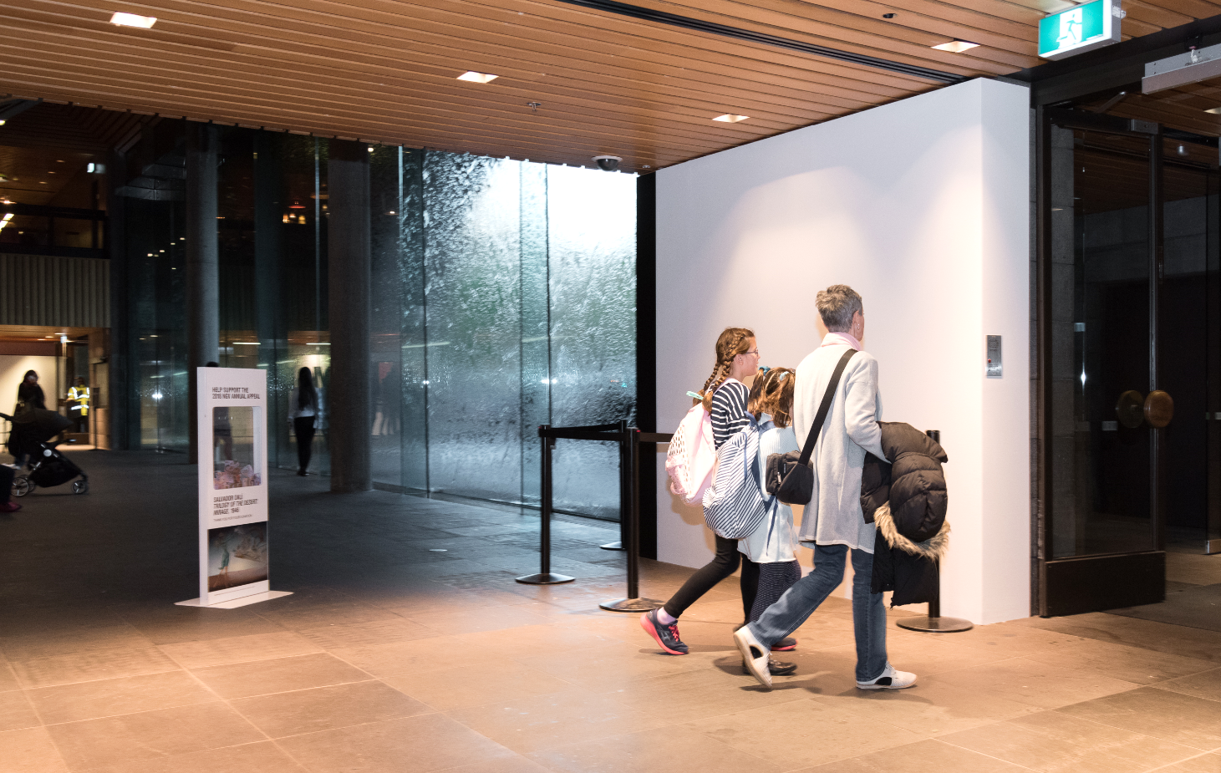

Going to the Gallery is fun.

